MyCommercialAD.com Progress Report

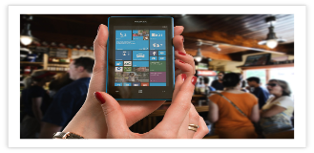

|  |  |  |  |  |  |
| --- | --- | --- | --- | --- | --- |
| **Status Report Date:** | | | 2019-09-10 | | |
| **Project team members:** | | | Clarence Mitchell | | |
| **Advisor name:** | | | Dr. Eric Tao | | |
| **Client/Sponsor name (if applicable):** | | | N/A | | |
| **Status Period:** | **From:** | September 3, 2019 | | **To:** | September 10, 2019 |

Cost performance [cost variance] % under/over estimated hours

Schedule performance [schedule variance] % ahead/behind schedule

|  |  |
| --- | --- |
|  | $ or #of hours |
| Planned hours to date | 42 Hours |
| Actual hours to date | 35 Hours |
| Approved total project hours | 42 Hours |
| Estimated total hours at completion | 35 Hours |

Issues requiring advisor/client attention

None.

2

Changes to scope, schedule, hours during this period

1 None

2

Major problems encountered and planned action to resolve

1 None

Issues identified this period and required action

1 None

2

Major accomplishments in the past period

1 Broke the tasks down in to several test projects that were easier to code and test

2

Client feedback from this week (if applicable)

1 N/a

2